**Assignment Question on 18-05-2023:**

1. **Find out which sequence is a walk, trail, cycle, path and Circuit of the following.**



1. **A, B, G, F, C, D**
2. **B, G, F, C, B, G, A**
3. **C, E, F, C**
4. **C, E, F, C, E**
5. **A, B, F, A**
6. **F, D, E, C, B**

**Specify walk is open or close.**

1. **Find whether the given graph is traversable. If so specify the solution.**



**Assignment Question on 19-05-2023**

**Is the following graph Hamilton or Eulerian or both? Justify your Answer.**



**Construct minimal Spanning Tree of the Following graph using Kruskal’s algorithm.**

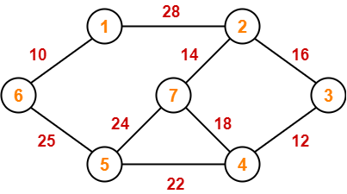

**Construct minimal Spanning Tree of the Following graph using Prim’s algorithm.**

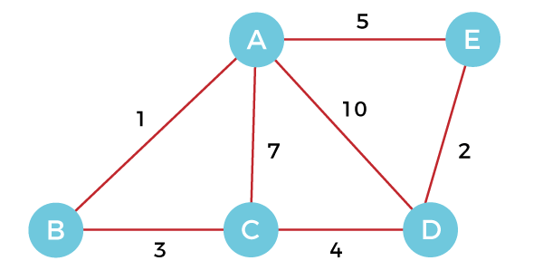

**Assignment Question on 20-05-2023:**

1. From a group of 10 professors how many ways can a committee of 5 members be formed so that at least one of Professor A and Professor B will be included?
2. State and Prove n(AUBUC) theorem using Principle of Inclusion and Exclusion
3. If there are 200 faculty members that speak French, 50 that speak Russian,100 that speak Spanish, 20 that speak French and Russian, 60 that speak French and Spanish, 35 that speak Russian and Spanish, while only 10 speak French, Russian, and Spanish, how many speak either French or Russian or Spanish?
4. If 6 color are used to paint 37 home. Show that at least 7 home of them will be of same colour.
5. A bag contains 10 red marbles, 10 white marbles, and 10 blue marbles. What is the minimum no. of marbles you have to choose randomly from the bag to ensure that we get 4 marbles of same color?
6. Find the minimum number of teachers in a college to be sure that four of them are born in the same month.
7. A box contain 10 blue ball, 20 red balls, 8 green balls, 15 yellow balls and 25 white balls. How many ball we have chosen to ensure that we have 12 balls of the same color.
8. Prove that among 1, 00, 000 there are two who are born on the same time.
9. In a computer science department, a student club can be formed with either 10 members from first year or 8 members from second year or 6 from third year or 4 from final year. What is the minimum no. of students we have to choose randomly from department to ensure that a student club is formed?

**Assignment Questions on 22-05-2023**

**1.** Prove whether the following two graphs is isomorphic or not.

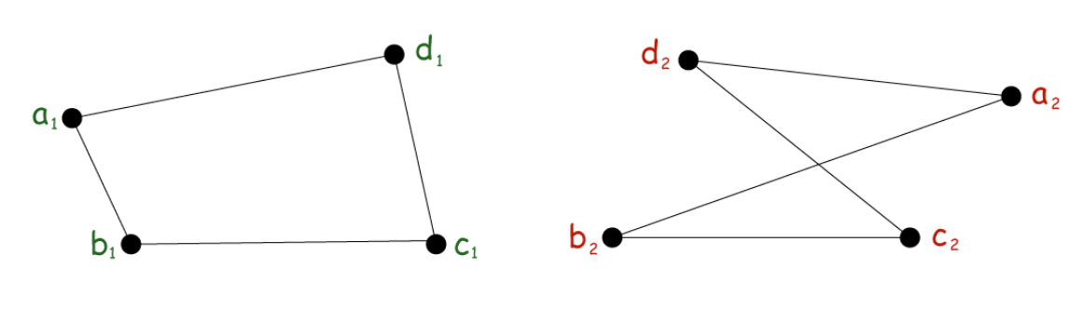

**2.** Illustrate Isomorphic graphs with the suitable examples.

3. Show the following two graphs is isomorphic or not using relabeling method.

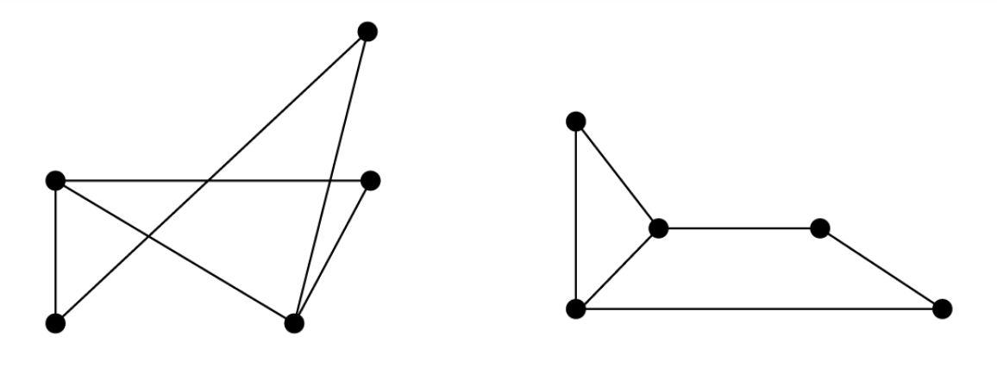

4. Show the following two graphs is isomorphic or not.

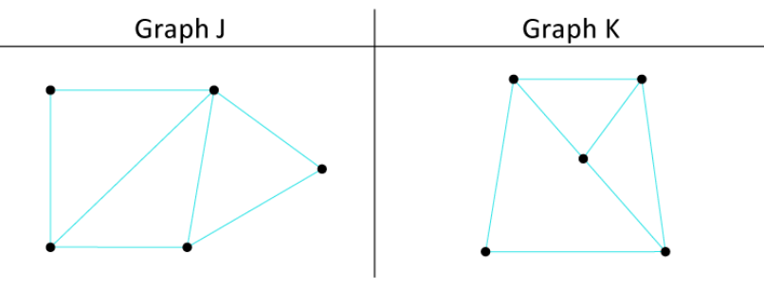

5. **Show the following two graphs is isomorphic or not.**

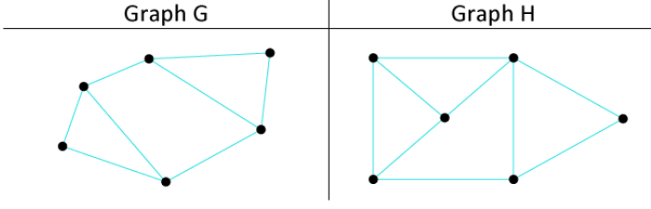

**6. Are the following two graphs isomorphic?**

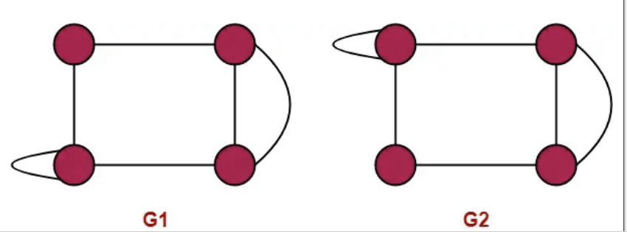

**7. Which of the following graphs are isomorphic?**

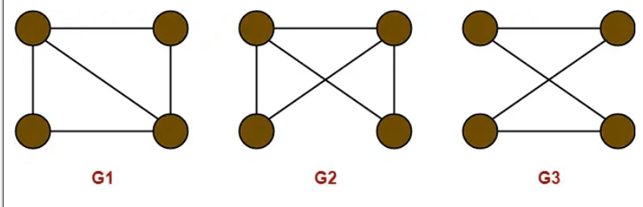

**8. Are the following two graphs isomorphic?**

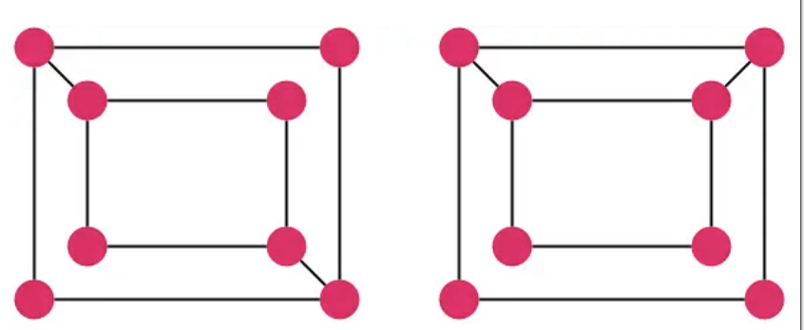

**Assignment Questions on 23-05-2023**

1. In how many ways can the letters of the word 'READER' be arranged?
2. How many ways can 12 white pawns and 12 black pawns be placed on the black squares of 8 X 8 chessboard?
3. In how many ways can a hand of 5 cards be selected from a deck of 52 cards?
4. From a group of professors how many ways can a committee of 5 members be formed so that at least one of professor A and professor B will be included?
5. In how many ways can 12 of the 14 people be distributed into 3 teams where the first team has 3 members, the second has 5, and the third team has 4 members?
6. Suppose that Florida state university has a residence hall that has 5 single rooms, 5 double rooms, and 3 rooms for 3 students each. In how many ways can 24 students be assigned to the 13 rooms